**Practical no. – 2**

**Aim:** write a program to create a new plot by rotating the given numbers by a degree 90, 180, 270 degrees

1. Rotation by 90 degrees

**Code:**

import numpy as np

import matplotlib.pyplot as plt

s = np.array([1+2j,2+3j,4+5j,5+6j,6+7j,3+4j])

l=np.array([z*1j for z in s])

print(l)

x = l.real

y = l.imag

plt.scatter(x,y,label="Comple number",color="b",s=25,marker="o")

plt.xlabel("Real number")

plt.ylabel("Imaginary number")

plt.plot(x,y)

plt.show()

**Output:**

[-2.+1.j -3.+2.j -5.+4.j -6.+5.j -7.+6.j -4.+3.j]

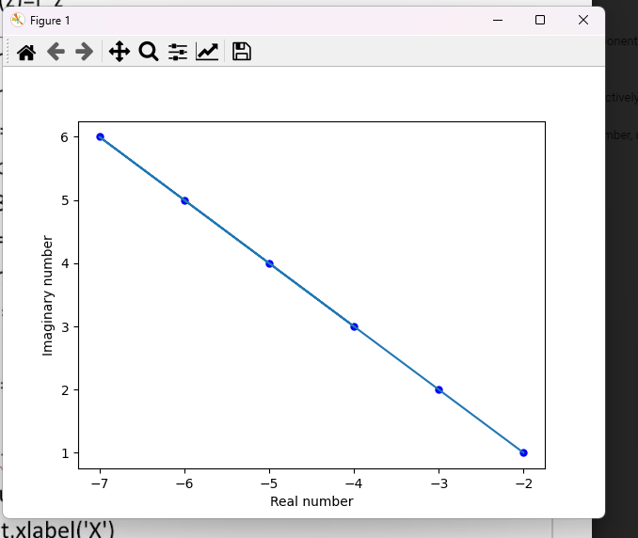

1. Rotation by 180 degrees

**Code:**

import numpy as np

import matplotlib.pyplot as plt

s = np.array([1+2j,2+3j,4+5j,5+6j,6+7j,3+4j])

l = np.array([z*-1 for z in s])

print(l)

x=l.real

y=l.imag

plt.scatter(x,y,label="Comple number",s=25,color="b",marker="o")

plt.xlabel("Real number")

plt.ylabel("Imaginary number")

plt.plot(x,y)

plt.show()

**Output:**

[-1.-2.j -2.-3.j -4.-5.j -5.-6.j -6.-7.j -3.-4.j]

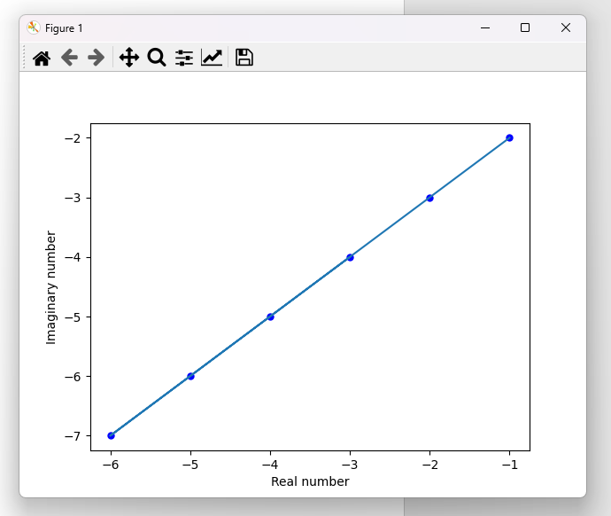

1. Rotation by 270 degrees

**Code:**

import numpy as np

import matplotlib.pyplot as plt

s = np.array([1+2j,2+3j,4+5j,5+6j,6+7j,3+4j])

# main logic "z*1j-1 for z in s"

# where s is the array of complex number

# iterates through every element in s and multiply every element by 1j-1

# z store the singal value i.e. 1+2j so on for each iteration

# as it is in the "[ ]" creates an list of new complex nums and using array method convert that into an array form

l = np.array([z*1j-1 for z in s])

print(l)

x=l.real

y=l.imag

plt.scatter(x,y,label="Complex number",color="b",s=25,marker='o')

plt.xlabel("Real number")

plt.ylabel("Imaginary number")

plt.plot(x,y)

plt.show()

**Output:**

[-2.+1.j -3.+2.j -5.+4.j -6.+5.j -7.+6.j -4.+3.j]

